EXPT NO:4 | Visual encoding of data
DATE: 20.01.2026 | Visual encoding of data

PRE-LAB QUESTIONS

- How does the human visual system process visual variables?

The human visual system quickly interprets visual variables such as position, size, shape, and colour to recognize patterns, trends, and differences without conscious effort.

- Why is improper encoding misleading in analytics?

Improper encoding can exaggerate or hide important data patterns, leading to misinterpretation and incorrect conclusions by viewers.

- What are perceptual limitations in visualization?

Perceptual limitations include difficulty distinguishing similar colours, accurately comparing areas or angles, and processing too many visual elements at once.

- How does colour choice affect interpretation?

Colour choice influences attention, readability, and emotional response, and poor colour selection can distort meaning or reduce accessibility.

- Why should AI dashboards be perceptually optimized?

Perceptually optimized AI dashboards improve clarity, reduce cognitive load, and help users make faster and more accurate decisions based on model outputs.

IN-LAB EXERCISE:

OBJECTIVE:

To apply effective visual encoding principles for meaningful data communication.

SCENARIO:

A city traffic department analyses accident data to identify high-risk zones and accident severity patterns.

IN-LAB TASKS (Using R Language)
• Encode severity using colour gradients
• Represent accident frequency using size
• Use shape to indicate accident type

Code:

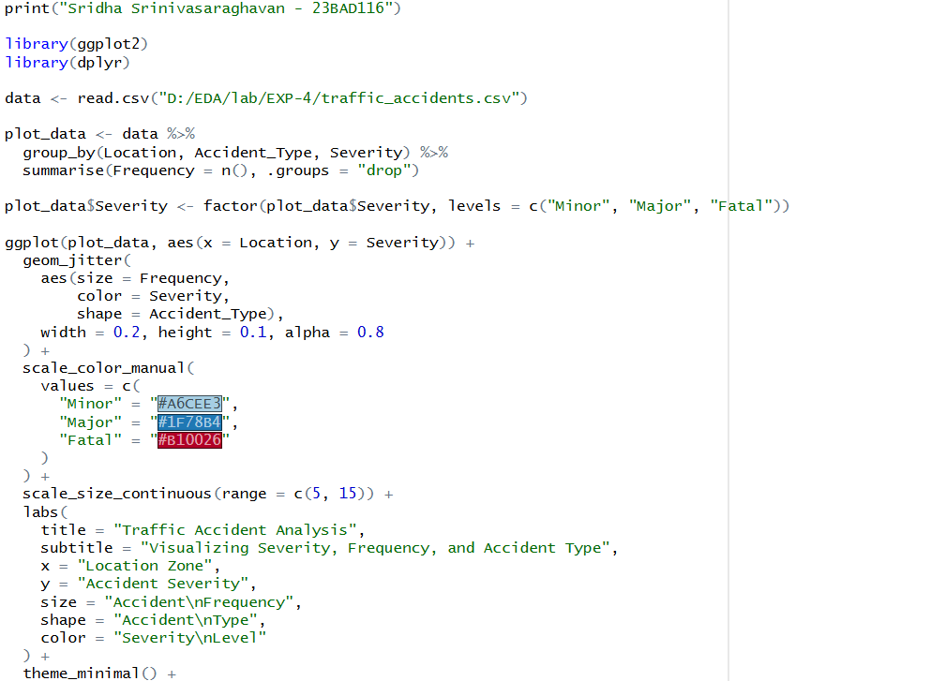


Output:




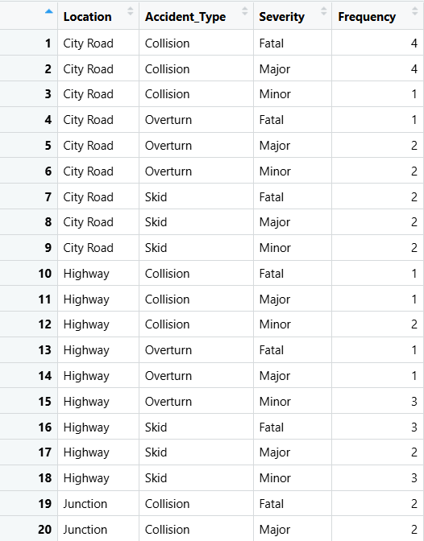

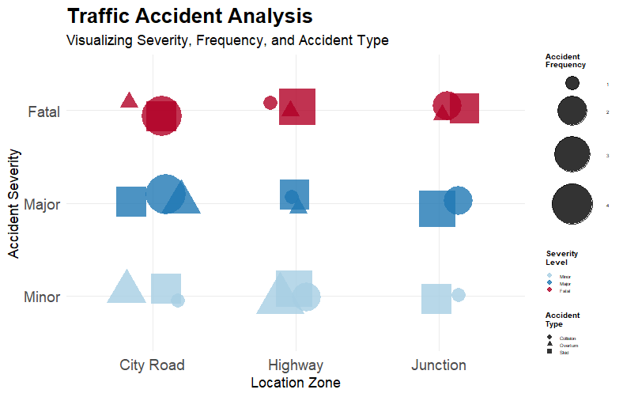

POST-LAB QUESTIONS

- Which visual variable best conveys severity and why?

Colour is the most effective visual variable for conveying severity because it is immediately perceived and allows quick differentiation of impact levels such as minor, serious, and fatal.

- How can poor encoding mislead policy decisions?

Poor encoding can exaggerate or hide critical patterns, leading policymakers to misidentify high-risk areas or underestimate severity, resulting in ineffective or incorrect interventions.

- What precautions should be taken for colour-blind users?

Use colour-blind-safe palettes, avoid relying solely on colour, and combine colour with shapes or labels to ensure accessibility for all users.

- How does visual encoding affect AI explainability?

Clear visual encoding helps users understand AI outputs and model reasoning, improving transparency, trust, and interpretability of AI-driven decisions.

- Suggest improvements for large-scale public dashboards.

Use simple layouts, consistent encoding, interactive filters, accessible colour schemes, and summarized views to handle large datasets without overwhelming users.

LEARNING OUTCOME: Students learn perceptually effective visual communication for AI systems.

ASSESSMENT
Description | Max Marks | Marks Awarded
Pre Lab Exercise | 5
In Lab Exercise | 10
Post Lab Exercise | 5
Viva | 10
Total | 30
Faculty Signature

